|  |
| --- |
| 05 |

**SPRING 2025 CSE 224 DIGITAL LOGIC DESIGN LAB** DATE: 13/ 03/2025

**PROJECT CONFIRMATION REPORT**

|  |
| --- |
| 65-C |

GROUP NO: SECTION:

|  |  |  |
| --- | --- | --- |
| GROUP  MEMBERS  NAMES & IDS | Name: Hridoy Kumar | ID: 232-15-013 |
| Name: Habibur Rahman | ID: 232-15-297 |
| Name: Obaidul Haque Buyan | ID: 232-15-350 |
| Name: Anup Barman | ID: 232-15-868 |
| Name: Md.Riyad Molla | ID: 242310005101897 |

**PROJECT TITLE:**  Design and Implementation of a Simple Radar System Using Ultrasonic Sensors and Arduino.

**PROJECT SUMMARY:**

This project aims to design and build a simplified radar system prototype capable of detecting objects and measuring their distance and approximate direction. Targeted at digital logic design (DLD) and embedded systems, the system uses ultrasonic sensors (HC-SR04) as a safe, low-cost alternative to radio frequency (RF) modules, paired with an Arduino-Uno for processing.

The radar system operates by emitting ultrasonic pulses and calculating the time delay of reflected echoes to determine object distance. A servo motor rotates the sensor to simulate a radar "sweep," enabling directional detection. The processed data is displayed on LEDs, a 7-segment display, or a simple LCD screen.

**Key tasks include:**

* Simulating signal processing algorithms ( pulse-echo timing ) in MATLAB/Python.
* Programming the FPGA/Arduino to control the sensor, servo, and output interface.
* Integrating hardware components and calibrating the system for accuracy.

**Learning Outcomes:**

* Hands-on experience in sensor interfacing, digital signal processing, and servo control.
* Practical application of DLD concepts ( VHDL/Verilog coding for FPGA users ).
* Problem-solving in hardware-software integration and noise reduction.

**Applications:**

* Educational tool for demonstrating radar principles.
* Foundation for advanced projects ( obstacle-avoidance robots or multi-sensor systems ).

This project emphasizes simplicity, cost-effectiveness, and accessibility while providing a gateway to real-world engineering challenges.

**CIRCUIT DIAGRAM:**

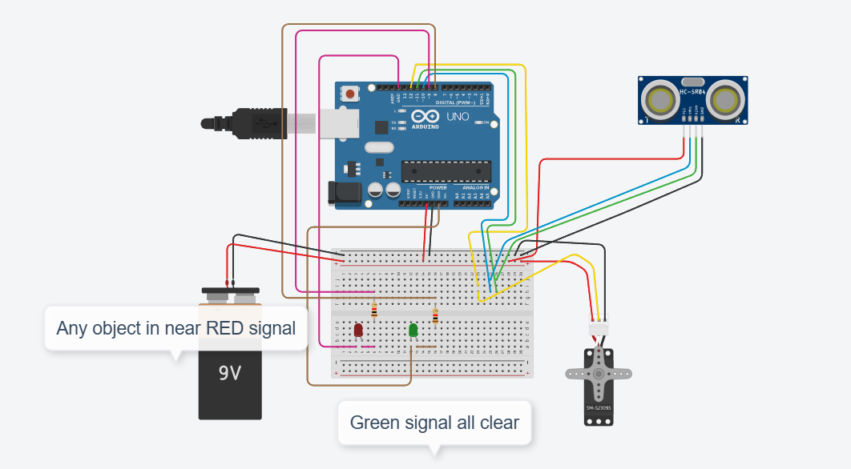

Diagram in tinkercad: *https://www.tinkercad.com/things/ga2MEGXUrEZ-radar-system-using-arduino-uno*

**CIRCUIT WORKING PRINCIPLE:**

A Radar (Radio Detection and Ranging) system is an electronic system used to detect, track, and measure the distance and speed of objects using radio waves. It works by transmitting electromagnetic waves and analyzing the signals that bounce back from objects. Here , Used (Servo motor,Ultrasonic sensor (HC-SR04),Arduino Uno)for basic object detection Radar System project.

**Components and Functionality:-**

* Arduino Uno → Main controller for processing sensor data and controlling components.
* HC-SR04 Ultrasonic Sensor → Sends and receives ultrasonic waves to detect object distance.
* Servo Motor → Rotates the sensor to scan a wider area.
* Breadboard & LEDs → Provides visual feedback for detected objects.
* 9V Battery → Powers the circuit.

1. **Power Supply and Initialization-**

* The 9V battery powers the Arduino board, which in turn powers the sensor, motor, and LEDs.
* The Arduino initializes the components and prepares the servo motor to rotate.

1. **Rotating the Ultrasonic Sensor-**

* The servo motor rotates from 0° to 180° in steps.
* The ultrasonic sensor scans the area by measuring the distance of nearby objects.

1. **Object Detection and Distance Calculation-**

* The HC-SR04 sensor sends an ultrasonic pulse.
* If an object is detected, the echo signal is received.
* The Arduino calculates the distance using: Distance $=\frac{Time×0.034}{2}$, (where 0.034 cm/µs is the speed of sound)

1. **Visual Alerts Using LEDs-**

* If an object is detected at a short distance, a red LED turns ON.
* If an object is not detected, a green LED turns ON.

1. **Display and Data Processing-**

* The Arduino processes the data and can send it to a computer for graphical display.
* The distance and angle data can be used for a radar-like visual representation.

**Circuit Connections:-**

**Ultrasonic Sensor (HC-SR04)-**

* VCC → 5V (Arduino)
* GND → GND (Arduino)
* Trig → Digital Pin ( D10)
* Echo → Digital Pin ( D11)

**Servo Motor-**

* Power (Red) → 5V (Arduino)
* Ground (Black) → GND (Arduino)
* Control (Yellow) → Digital Pin (D12)

**LEDs (Connected to Breadboard)-**

* Red LED → Digital Pin ( D9 and GND)
* Green LED → Digital Pin ( D8 and PWM)

**Power Supply-**

* 9V battery connected to Arduino’s VIN pin.

**Summary of Operation:-**

* The servo rotates the ultrasonic sensor across 180 degrees.
* The sensor measures distances and detects obstacles.
* LEDs turn ON/OFF based on object proximity.
* The system sends data to a display (optional) for visualization.
* The result is a real-time radar system that provides both visual and data-based object detection.

LIST OF COMPONENTS:

|  |  |
| --- | --- |
| **COMPONENT NAME** | **QUANTITY** |
| **Arduino Uno** | 1 |
|  |  |
| **Ultrasonic sensor (HC-SR04)** | 1 |
|  |  |
| **Servo motor (for scanning)** | 1 |
|  |  |
| **Buzzer/LED (for alert signals)** | 2/3 |
|  |  |
| **LCD/OLED display (optional)** | Optional |
|  |  |
| **Power supply / Battery** | 1 |
|  |  |
| **Breadboard** | 1 |
| **Resistor** | 2 |
| **Jumper wires** | 6/8 pair |

**SIGNATURE:**

Name: Hridoy Kumar

Date: 13-03-25

Name: Obaidul Haque Buyan

Date: 13-03-25

Name: Habibur Rahman

Date: 13-03-25

Name: Md.Riyad Molla

Date: 13-03-25

Name: Anup Barman

Date: 13-03-25